Google Sites Quick Start Guide

Access Google Sites
Using a web browser, go to site s.go o gle.c o m . Enter your full site email address, then click Sign In. Next, enter your Net-ID and password, then click Login to continue.

Create a Goo gle Si te
Create New Page
Edit a Page
- Locate the page you wish to edit.
- Click the Edit (pencil) button, in the top right toolbar, to edit the page.
- Make your changes.
- Click the Save button to save changes.

  - 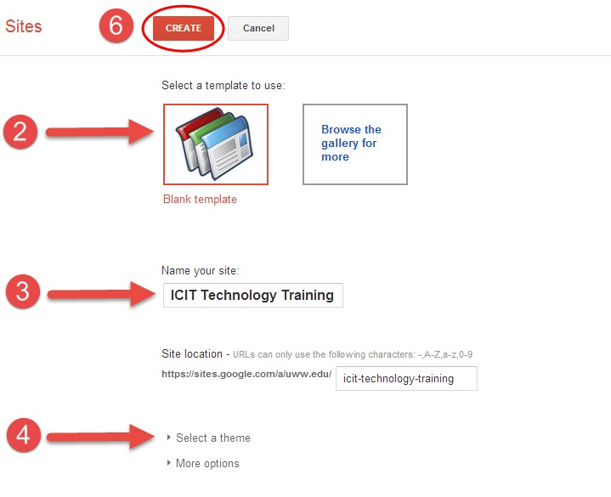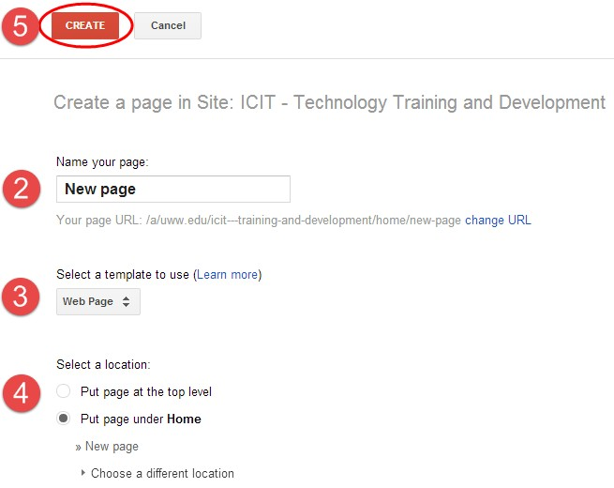From your Google Sites page, click the New Page
button

Edit Page Toolbar

- From the Google Sites main webpage, click the Create
button located in the left-hand toolbar.
- Select Blank Template to start a new blank site or select “Browse gallery for more” to view site templates.
- Enter a name for your site in the “Name your Site” text box available. NOTE: The site location will fill in automatically for you.
- Click the “Select a theme” drop down box to view available background themes for your site. Click on a theme to select it.
- Click the “More options” dropdown box to enter a site cate-
gory and/or description, if you wish.

- Click the Create button, from the top toolbar, to create your site.

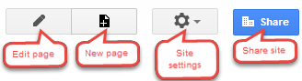 Sites Too lbar
- Enter the name for your new page.
- 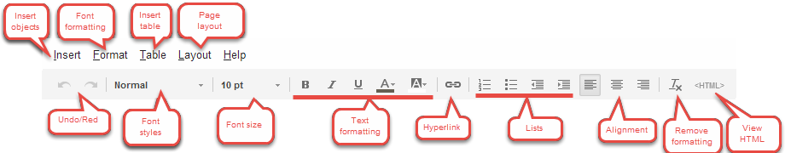Select a page template. “Web Page” is the default page for a website.
- Select the page location. “Top level” puts the new page directly under the Home page. “Put page under” will put the new page under another page.
- Click the Create button to create your new page.

Delete Page
- Click the Settings button located in the top right toolbar.
- Select Delete Page from the drop down menu.

Copy Page

- Click the Settings button located in the top right toolbar.
- Select Copy Page from the drop down menu.

Insert Objects

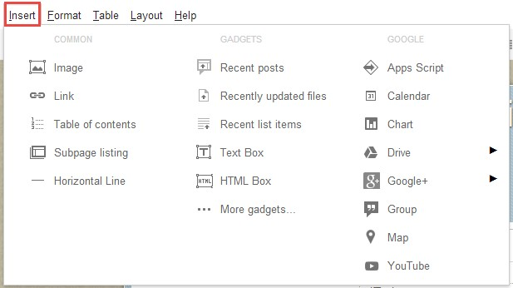
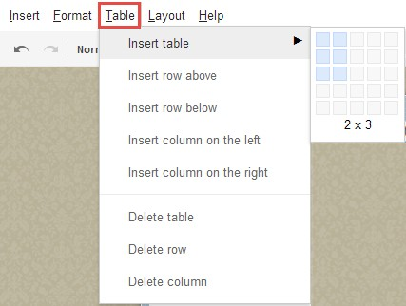 Insert Table

Google Sites Quick Start Guide

Change Page Layout

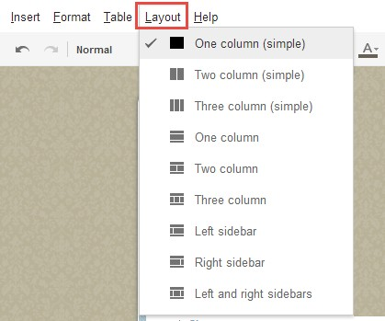

- Click the Edit (pencil) icon to edit your page.
- Click the Layout tab to view page layout options.

Insert Table o f Contents
- Click the Edit (pencil) icon to edit your page.
- Click the page area where you would like to insert the table of contents.
- Click the Insert tab from the top left toolbar.
- Select Table of Contents.
- Select your Table of Contents properties.
- Click Save to save your changes.
- Click the Save button, located in the top right corner of the page, to save your page and view your table of contents.
NOTE: The Table of Contents is built based on the “heading” font used on the page. To change a section to a “heading”, se- lect your text, click the Format tab from the top toolbar, then select Heading (H2), Sub-heading (H3) or Minor Heading (H4).

Advanced Page O ptio ns
Advanced site settings and options can be found by clicking the
Settings button located in the top right toolbar.

Embed a Google Doc
- Click the Edit (pencil) icon to edit your page.
- Click the Insert tab from the top left toolbar.
- Select Drive, then choose your Google application.
- Locate your document in Google Drive. Then click the
Select button.
- Set your document properties, including height and width. Click Save to continue.
- Use the “Object toolbar” to adjust your document properties, alignment and size.
- Click the Save button, located in the top right toolbar, to save your page and view your Google document.
Note: Your Google document must be “shared” for others to view. Set your document “sharing” permissions within the document in Google Drive.

Insert a Hyperlink
- Click the Edit (pencil) icon to edit your page.
- Copy and paste a hyperlink into your page or highlight the text to hyperlink.
- Click the Add/Remove link button. If Google detects a hyperlink, there is nothing more you need to do, otherwise follow the remaining steps below.
- Select “Sites page” to link to another page under Google Sites. Select “Web Address” to copy and paste a full web address url to an outside address.
- Click the “Open this link in a new window” option if you would like the page to open in a new window.
- Click the OK button to save your hyperlink.
- Click the Save button, in the top right toolbar, to save your page and view your hyperlink.

Google Sites Quick Start Guide

