Valley ROP
Fire Fighting Pathway overview

Valley Regional Occupational Program (ROP) in conjunction with Kings Canyon Unified School District, Reedley College, Fresno City College and the City of Reedley, offers a Fire Fighting pathway program where students can learn the basics Fire Fighting skills and earn important industry certifications in order to become a Fire fighter.

Students first take the "Urban/Rural Fire Fighting" class during the Junior year, and the "Wildland" fire fighting course as Seniors. The classes are designed to give students all the basic tools, skills, certifications and knowledge to become paid call firefighters, enter the fire academy or work for the US Forest Service in a wide array of jobs. Summer paid internships are available to all the successful students through the Reedley Fire Department and the US Forest Service.

Because of the strong partnership between Valley ROP and the State Center Community College district, students can earn up to 16 college units by taking advantage of the "Dual Enrollment". The college courses, textbooks and materials are free for the KCUSD students who enroll in the Fire Fighting pathway.

Class Description:
U/R Fire Fighting (Juniors) – Class is held at Reedley Fire Department
Course Description: 2-hour block with approximately 5 Saturday field days. This course is designed to prepare individuals for fighting fires and related tasks. The course is the California State Fire Marshal Fire Fighter I course which prepares students for State certification. Students will learn about fire protection organizations, use and handling of firefighting equipment and apparatuses, fire protection and safety, fire behavior and extinguishment methods, rescue and ventilation operations, fire control, and salvage and overhaul of structures.

Wildland (Seniors Only) – Class is held at Reedley College
Course Description: 2-hour block with 5 Saturday field days. This course introduces students to the USDA Forest Service (USFS) and prepares them with basic firefighting and conservation entry-level skills. Classroom instruction, demonstration, and hands-on field application will be given in basic firefighting, standards for survival, engine and pump operations, backfiring methods and equipment use, chainsaw operations, map and compass use, air operations, basic hand tool sharpening and use, fire line construction, and forest conservation.

Industry Certifications:
CPR, First Aid & Safety
EMS Training (Prep Course for EMT Cert)
I-100 (Incident Command System) Certification
I-200 (Incident Command System) Certification
S-190 (Wildland Fire Behavior) Certification
S-130 (Firefighter Training) Certification
S-212 (Wildland Power saws) Certification
S-211 (Portable Pumps) Certification

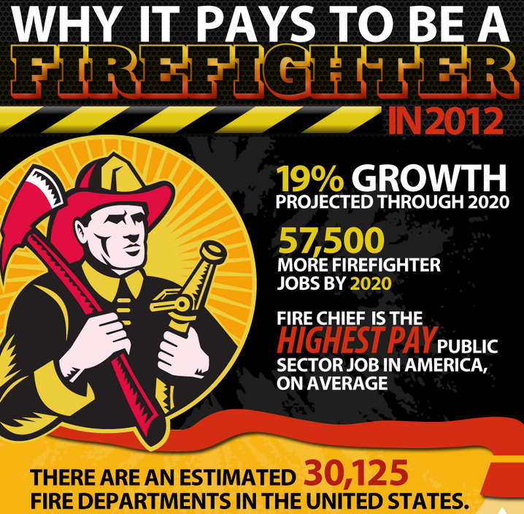
Senior Year
Wildland Fire Fighting
(Summer Job Placement)

Reedley College

Natural Resource

US Forest Service

Fresno City College

Fire Academy

City Fire Fighter

Junior Year
Urban/Rural Fire Fighting
(Summer Paid Internship available)

Sophomore Year
Medical Terminology
Freshman Year
Principles of Law Enforcement & Public Safety

Full Fire Fighting Pathway

